Learning objectives: | Types of activities:
- continue to apply phonic knowledge and skills as the route to decode words until automatic decoding has become embedded and reading is fluent  - read accurately by blending the sounds in words that contain the graphemes taught so far, especially recognising alternative sounds for graphemes  - read accurately words of two or more syllables that contain the same graphemes as above  - read words containing common suffixes  - read further common exception words, noting unusual correspondences between spelling and sound and where these occur in the word  - read most words quickly and accurately, without overt sounding and blending, when they have been frequently encountered  - read aloud books closely matched to their improving phonic knowledge, sounding out unfamiliar words accurately, automatically and without undue hesitation  - reread these books to build up their fluency and confidence in word reading | Shopping lists, writing for a purpose (cards, letters).  Contractions- can’t, don’t etc. look for these in texts.
- develop pleasure in reading, motivation to read, vocabulary and understanding by:  - listening to, discussing and expressing views about a wide range of contemporary and classic poetry, stories and non-fiction at a level beyond that at which they can read independently  - discussing the sequence of events in books and how items of information are related  - becoming increasingly familiar with and retelling a wider range of stories, fairy stories and traditional tales  - being introduced to non-fiction books that are structured in different ways  - recognising simple recurring literary language in stories and poetry  - discussing and clarifying the meanings of words, linking new meanings to known vocabulary  - discussing their favourite words and phrases  - continuing to build up a repertoire of poems learnt by heart, appreciating these and reciting some, with appropriate intonation to make the meaning clear  - understand both the books that they can already read accurately and fluently and those that they listen to by:  - drawing on what they already know or on background information and vocabulary provided by the teacher  - checking that the text makes sense to them as they read, and correcting inaccurate reading  - making inferences on the basis of what is being said and done  - answering and asking questions  - predicting what might happen on the basis of what has been read so far  - participate in discussion about books, poems and other works that are read to them and those that they can read for themselves, taking turns and listening to what others say  - explain and discuss their understanding of books, poems and other material, both those that they listen to and those that they read for themselves | Reading comprehension sheets included.  Reading books provided.
- spell by:  - segmenting spoken words into phonemes and representing these by graphemes, spelling many correctly  - learning new ways of spelling phonemes for which 1 or more spellings are already known, and learn some words with each spelling, including a few common homophones  - learning to spell common exception words  - learning to spell more words with contracted forms  - learning the possessive apostrophe (singular) [for example, the girl’s book]  - distinguishing between homophones and near-homophones  - add suffixes to spell longer words including –ment, –ness, –ful, –less, –ly  - apply spelling rules and guidance, as listed in English appendix 1  - write from memory simple sentences dictated by the teacher that include words using the GPCs, common exception words and punctuation taught so far | Creating a diary for each day of the week- working on writing a recount (using past tense verbs, and conjunction).  Shopping lists of items.  Role play opportunities to write for a range of purposes.
- form lower-case letters of the correct size relative to one another  - start using some of the diagonal and horizontal strokes needed to join letters and understand which letters, when adjacent to one another, are best left unjoined  - write capital letters and digits of the correct size, orientation and relationship to one another and to lower-case letters  - use spacing between words that reflects the size of the letters  - develop positive attitudes towards and stamina for writing by:  - writing narratives about personal experiences and those of others (real and fictional)  - writing about real events  - writing poetry  - writing for different purposes  - consider what they are going to write before beginning by:  - planning or saying out loud what they are going to write about  - writing down ideas and/or key words, including new vocabulary  - encapsulating what they want to say, sentence by sentence  - make simple additions, revisions and corrections to their own writing by:  - evaluating their writing with the teacher and other pupils  - rereading to check that their writing makes sense and that verbs to indicate time are used correctly and consistently, including verbs in the continuous form  - proofreading to check for errors in spelling, grammar and punctuation (for example, ends of sentences punctuated correctly)  - read aloud what they have written with appropriate intonation to make the meaning clear | 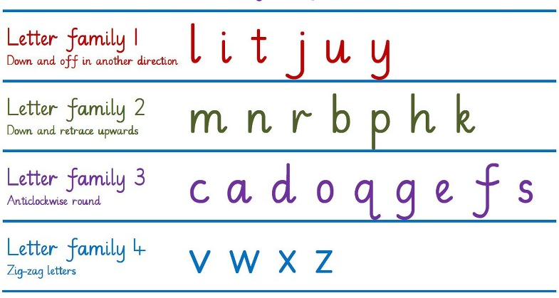  Rhyming poems- Brown Bear, brown bear.  Writing book/film reviews.  Writing a diary- past tense, present tense, future tense.

