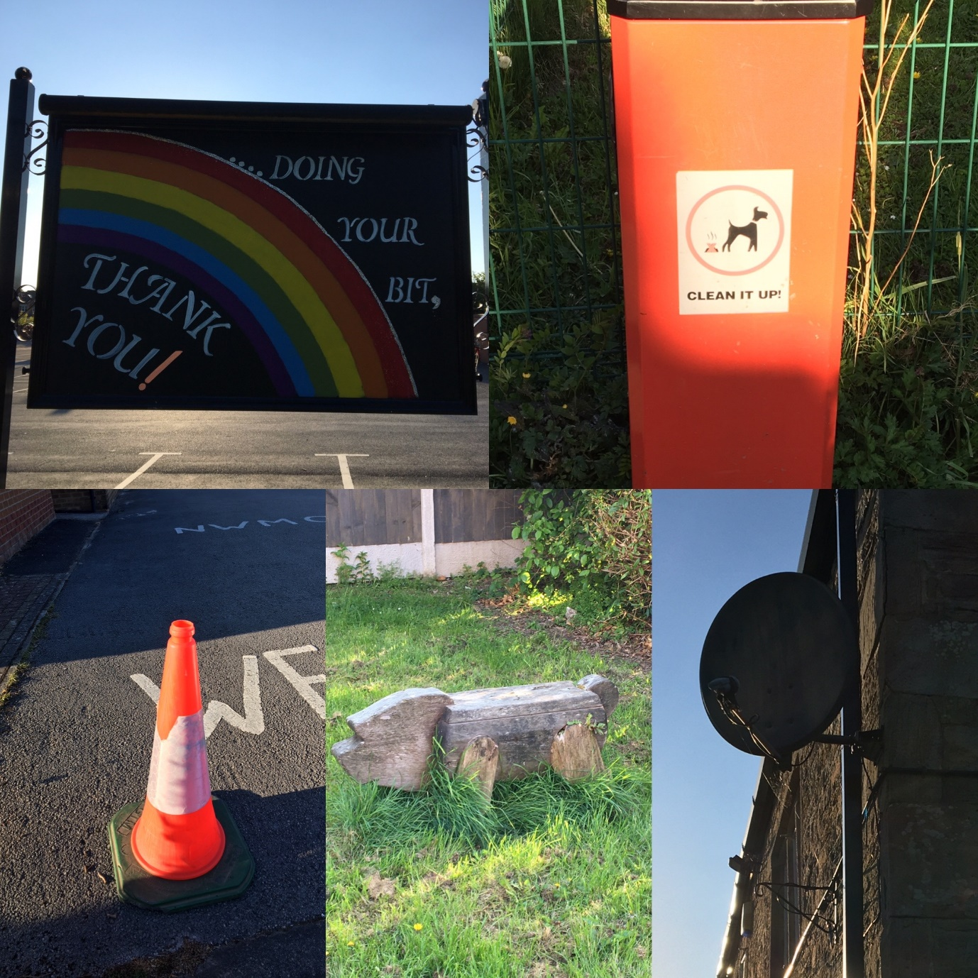

Walking Bingo
Here is a fun task for you to complete during your daily walk.
See how many objects you can find! Some are trickier than others. E.g. a traffic light, a snail shell, a bus stop sign.
Your task is to find as many as you can- Can you get a line? Can you get a full house?
Good Luck!

