Working from home in science – Mrs Eyre
Thursday 25th June
Hello all, this is for everyone!
Our scientist of the week is Maria Sibylla Merian, the woman who turned science into art. Watch this video and/or read the word document to find out why she is considered to be such an amazing role model and scientist.
https://www.youtube.com/watch?v=HObBdRBuV_0&safe=active
Be a ‘Maria Sibylla Merian style’ science ambassador and take a sketch pad and pencil outside. Find some interesting natural science to sketch. Try to observe objects very closely and include minute detail in your drawings.
Y3/4 Why do we need bees?
Bees play an important role in pollinating flowers. Watch these videos to find out more.
https://www.youtube.com/watch?v=6CxCTyxRFh0&safe=active
https://www.youtube.com/watch?v=Lu7AjOvznh8&frags=wn&safe=active
How do bees pollinate flowers?
Why is pollination important?
What other creatures pollinate plants?
How are fields of crops, like wheat, pollinated?
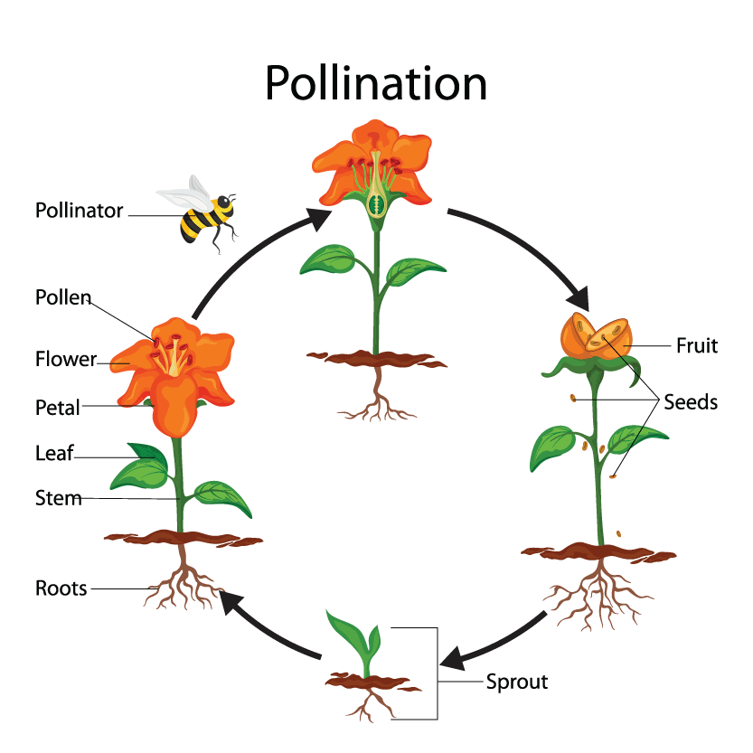
Choose a pollinator (other than bee) and show, using drawings and labels, how it is an important part of the plant’s life cycle.

eg

Y5/6 What are the mechanics of pollination?
Watch these videos about pollination.
https://www.sciencelearn.org.nz/resources/77-pollination-and-fertilisation
https://www.youtube.com/watch?v=YqM6rgB_l_o
https://www.youtube.com/watch?v=KMQtLWpAdXI
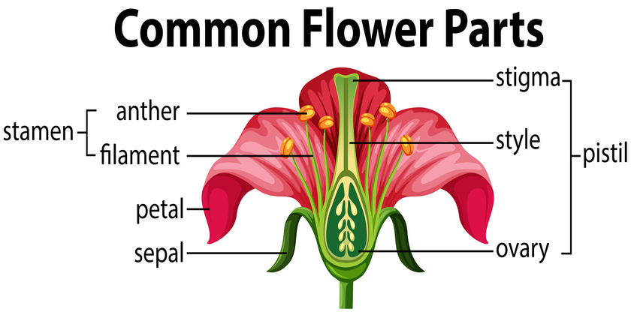
The diagram below shows the common flower parts, necessary for pollination. Take a moment to learn the names and functions of the different parts.
Look at flowers in your garden/locality and see if you can identify these parts on different flowers. Ask a grown up if it is safe/appropriate to pick a flower to dissect it and look more closely. Remember they may be poisonous.
Make a detailed labelled diagram of your flower, explaining what each part of the flower is and its role in pollination.

