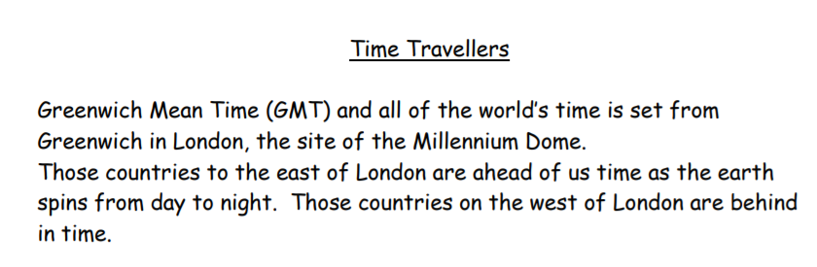
Use the website to find how far behind or in front of the UK these countries are. https://www.timeanddate.com/worldclock/
