L.O. I can build tension and suspense in a story

Go through the power point.

Look at the pictures below:

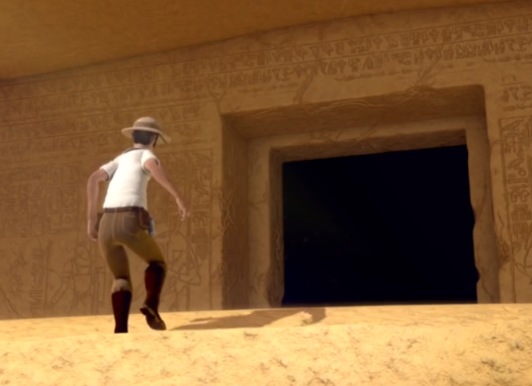 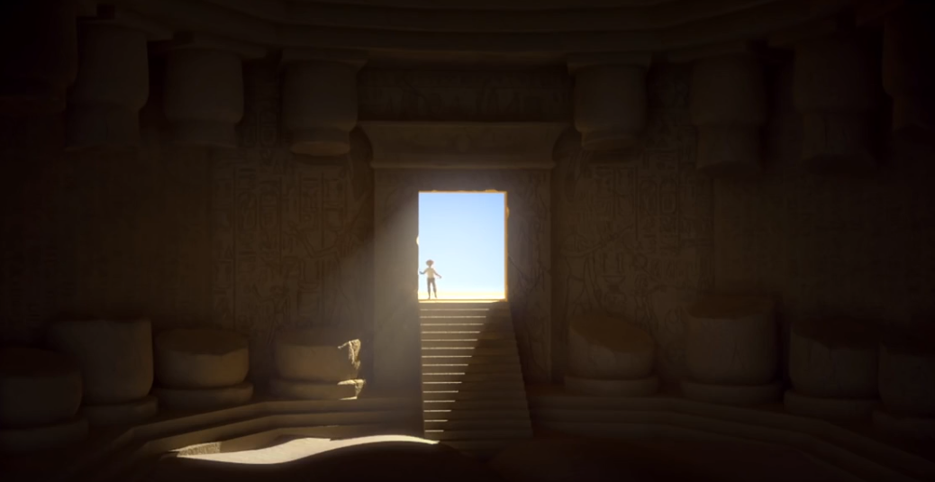

Write about how he felt:

As he approached the tomb.

Entering the tomb.

What he saw inside.

