+Day 1 Escape to the Pole – Chapter 8
I worked in the Navy Yard for a year, fetching and carrying but always dreaming of adventure. One day, Officer Peary came to find me.
“Matthew! Matt Henson!”
I heard him shout for me. I was in the middle of taking a message from one office to another and I couldn’t really stop, but Peary walked alongside me. His eyes shone as if he’d just been given the best present anyone could wish for.
At last I was going to the Arctic. We set sail in the autumn of 1890 and we reached the coast of Greenland a month or so later. I must admit I was a little disappointed. Instead of vast plains of white as far as I could see, there were only treeless hills and snow-capped mountains.
We set off from camp in June 1891 and our expedition reached the far north of Greenland. Peary said we should make a journey up the glacier and onto the ice cap to see how far we could get. Ahnalaka and Iwah tried their best to persuade us not to go out onto the ice, but Peary told them that was why he was here: to find a way to the North Pole.
The climb out of the glacier was almost impossible. There were hundreds of pressure ridges and crevasses. They were so deep and dark you could not see the bottom. We managed to avoid them but I saw why you might think there was a devil waiting to eat you whole down there. I remember what my sister Eliza had said to me all those years ago, about the monsters who wait for you down in the dark.
We travelled north for over a month, then very bad storms blew up that kept us in our igloos and, even worse, the dogs became ill and some of them died. Peary told me he and Astrup, the skier, would go up onto the ice cap but that I should take the last few dogs back to camp.
Ahnalka and Ikwah were very happy to come back to camp. We waited for the others but days passed and there was still no sign of them.
Many days later, Peary and Astrup returned. They were starving and exhausted but Peary was excited. They had travelled four hundred miles out of the ice cap, farther north than he had ever been.
The Kite was due to set off for home. In spite of the expedition going places no one had ever been before, the journey home was a gloomy one.
That first trip was the beginning of over nineteen years working with Peary and travelling to the frozen north. We didn’t know it then but it would take us all that time and four more expeditions to make it to the North Pole.
L.O. I can answer comprehension questions
Read the extract and answer the following questions:
Years 3 and 4
- Who asked him to travel to the Arctic?
Officer Peary asked him to travel to the Arctic.
- What part of the Arctic were they going to? Find this on a map
They were going to the North Pole.
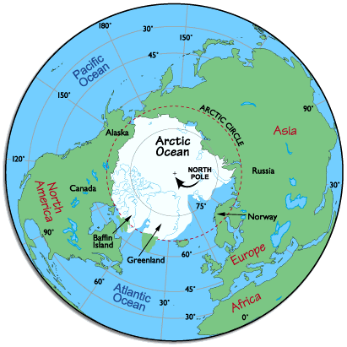

- How long did it take them to reach the Arctic?
It took them 1 month to reach the coast of Greenland.

- Is a glacier: a) an ice cream?
b) snowy land?
c) moving ice?
d) a mountain covered with ice?
If you are not sure, please look it up.

- “There were hundreds of crevasses.” What do you think, from reading the paragraph around this quote, that crevasses are?
I think that crevasses are when icebergs crack and move apart and form a hole.

- What made the journey take so long? (Paragraph starting We travelled North)
They were slowed down by many bad storms.

- Did his experience make him want to repeat it or never go there again? Explain with a quote from the text.
His experience made him want to do it again because the text says that ‘That first trip was the beginning of over nineteen years working with Peary and travelling to the frozen north. We didn’t know it then but it would take us all that time and four more expeditions to make it to the North Pole.’

Years 5 and 6
Please answer the following questions in as much detail as possible, stating your opinion, supported with evidence from the text.
- What clues are there in the text to tell you Peary was happy to have Matt Henson go with him?
He was happy to have Matt Henson going with him because as he approached, he said. ‘his eyes shone as if he’d just been given the best present anyone could wish for.’
- How do you think his experience in the Navy yard would help him with his trip?
His experience at the navy yard would help him as he was ‘fetching and carrying’, so would have built up his strength and stamina. (I had to describe to the class what a navy yard was.)
- Do you think it was a good time for them to set off to Greenland? What makes you think this?
No, as it was Autumn, so the weather would be poor.
Yes, as the ice would be firm to travel on as it was approaching winter.
- What, according to the text, was the only way to reach the North Pole?
The only way to reach the North Pole was ‘across the ice’.
- Why do you think Matthew was so careful when climbing near the crevasses?
He was careful as the crevasses were the edge of deep ravines, ‘so deep and dark, you could not see the bottom’
- I could describe the journey as perilous. Look up the word in a dictionary and write down 3 things that happened which could be described as perilous.
Deep ravines, snow storms, pressure ridges, starvation and exhaustion, lack of equipment and dogs.
- Why do you think the journey home may have been a gloomy one?
They did not reach the pole, dogs died.
- Did his experience make him want to repeat it or never go there again? Explain with a quote from the text.
Repeat it – as it says , ‘That first trip was the beginning of over nineteen years working with Peary and travelling to the frozen north.’
Not go again as he faced bad weather, exhaustion and starvation.

