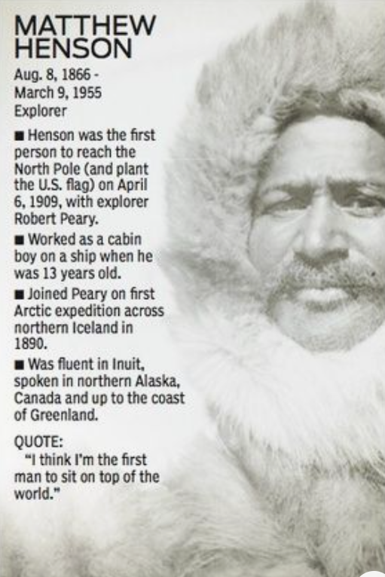
Day 4 L.O. I can write bullet points to summarise key points in my life
Read the bullet points above to find out more about Matthew Henson.
In the same style, write 4-10 bullet points which summarise key points in your life.
Remember to write a quote (from yourself or from another person about you.

