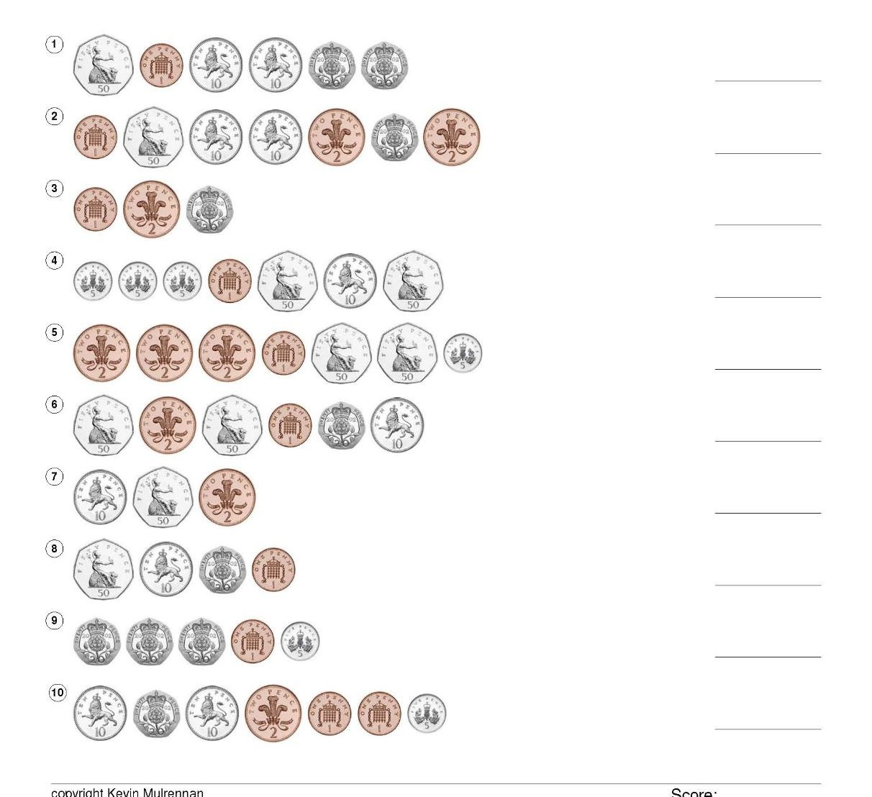
Use real coins to work these out Look for the coin with the largest value first.

