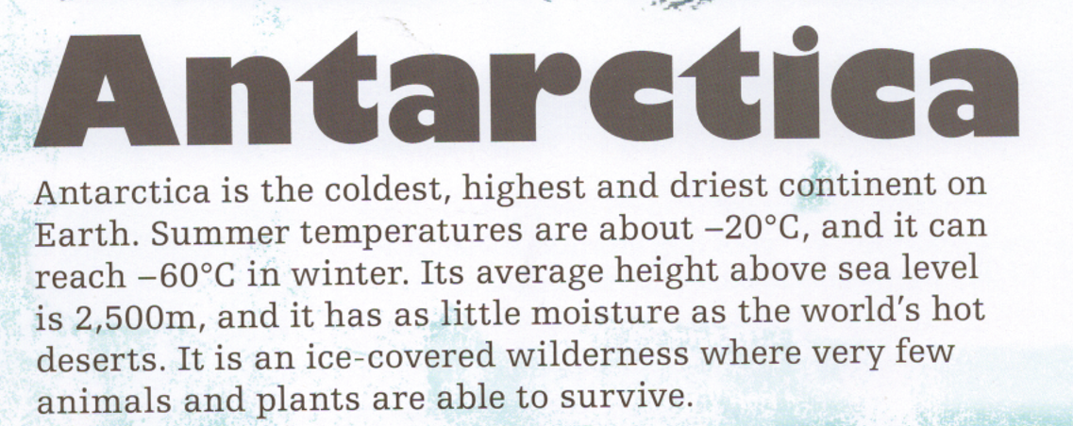
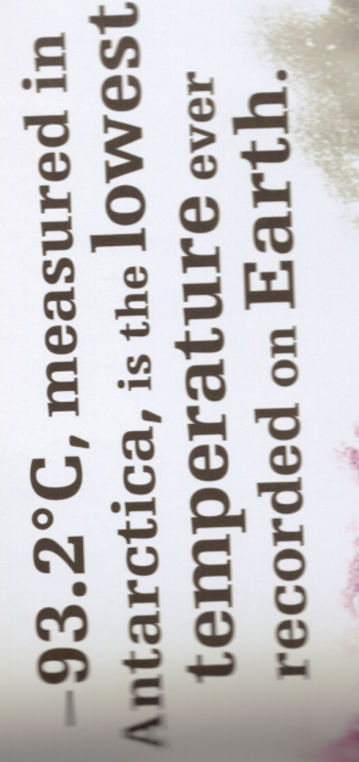
- What was special about Felicity Aston? Give at least 2 facts.
- Why do you think Antarctica measured the lowest temperature on Earth? Explain by using facts from the text above.
- What country would you compare Antarctica to being similar to? Explain your reasoning.
- It is described as a ‘wilderness’. Why do you think this?

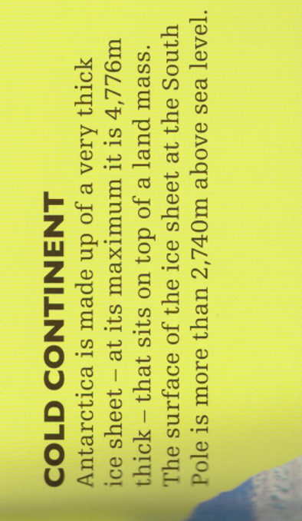
- A Kelvin is a base unit for measuring temperature. Why is Absolute Zero described as ‘theoretical’?
- Do you think Antarctica can be explained as land or ice? Explain your opinion.
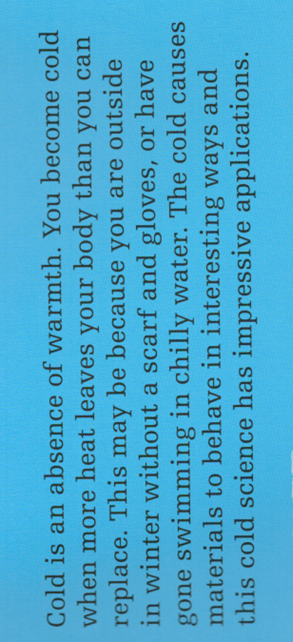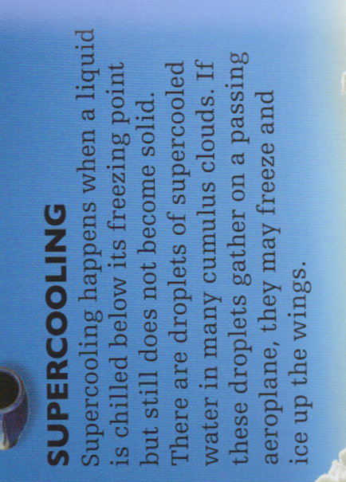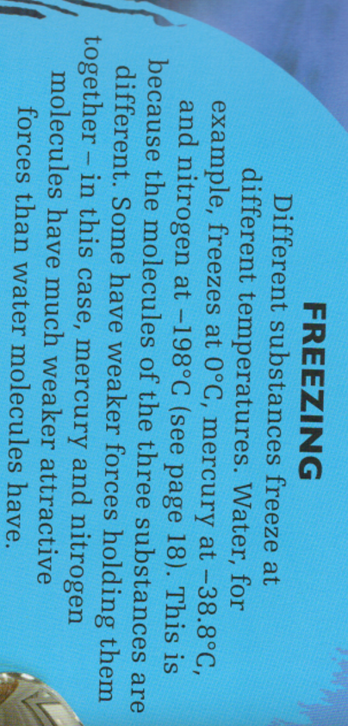
- Using the text, what can you do to help keep you warm?
- Where can you find evidence of supercooling?
- Which has the strongest molecules, water or nitrogen?

