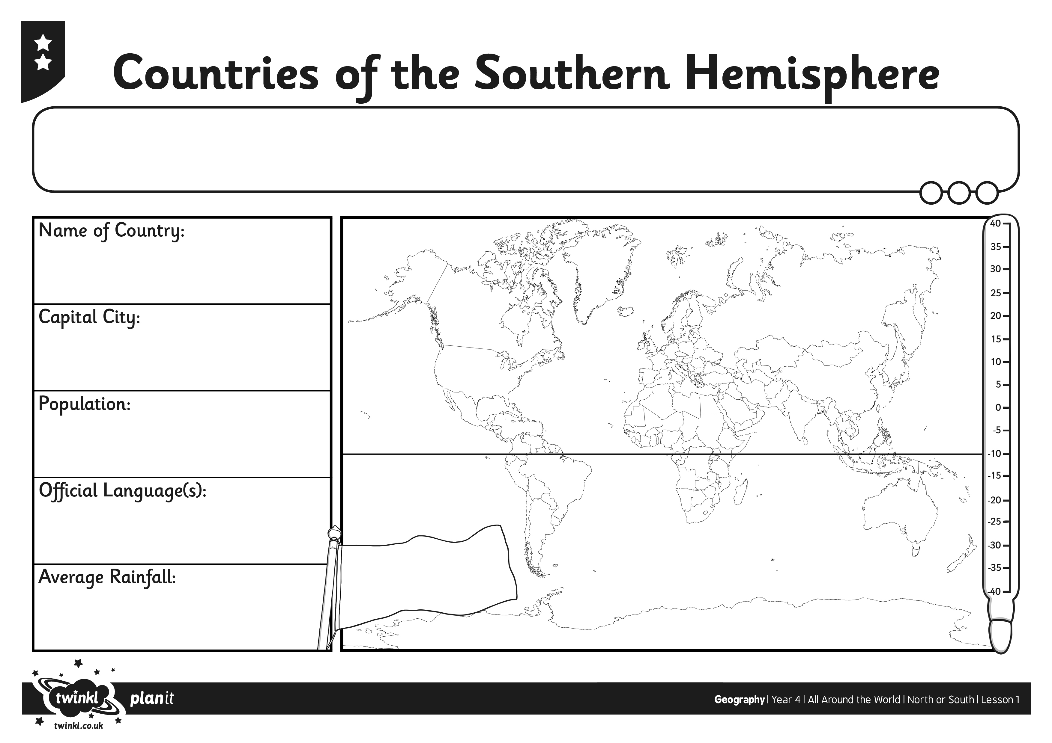
L.O. I can find out about a country in the Southern Hemisphere.

