L.O. I can extract information from a Biography – Usain Bolt
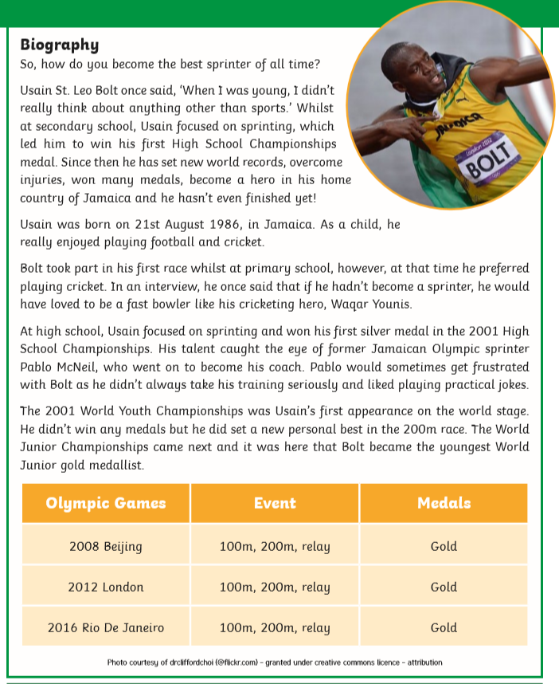
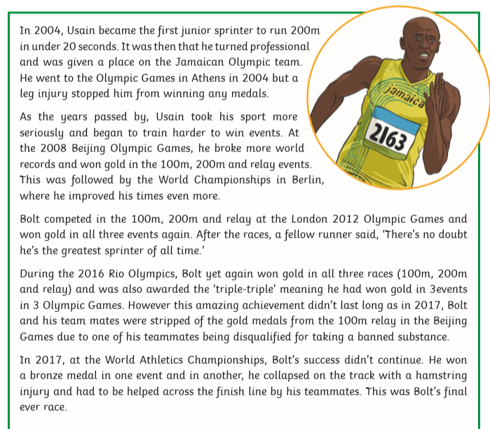
Y5/6
- When and where was Usain Bolt born?
- What did Usain become the first sprinter to do in 2004?
- How do you think Bolt felt when he was chosen to represent his country in the Olympic Games?
- How many gold medals did he win in the 2008, 2012 and 2016 Olympic Games?
- How do you think Usain felt after the 2017 World Championships? Explain your answer with reasoning from the text.
Y3/4 (Answers on Page 1 of the text only. Please write in full sentences.)
- What is Usain’s full name?
- What was the first medal he won?
- What country was he born in? (Extension – look up the flag for this country and draw it.)
- At Primary School, did he prefer running? Explain your answer.
- Who was his coach? Where did he first meet him?
- Which Olympic Games did he win his firt gold medal? What races were these for?

