Countries where penguins can be found
Penguins are found in Antarctica.
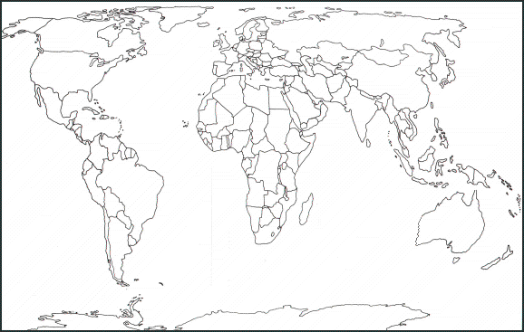
Use a blank map of the world to locate where penguins can be found around the world.
- Ecuador (Galapagos Islands)
- Peru
- Chile
- Argentina
- Uruguay
- Brazil
- Angola
- Nambia
- South Africa
- Mozambique
- Australia
- New Zealand
Can you draw a line where the Equator is?
What do you notice about the countries penguins can be found?

