How to survive in the South Pole
If you are going to survive, you need to build somewhere to live. We haven’t any snow at the moment but could you build a model igloo?
You could use lego, marshmallows, ice cubes etc.
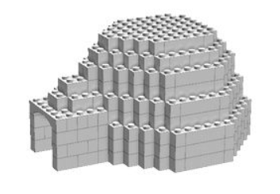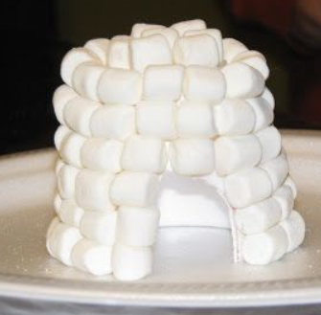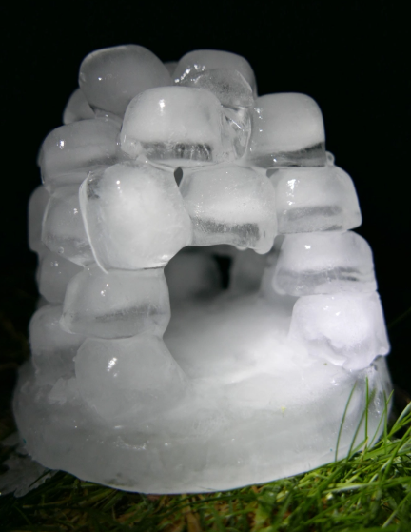
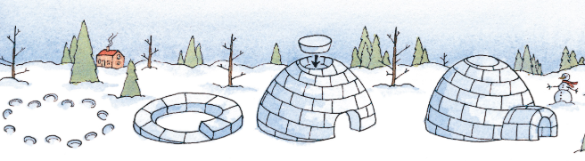
Design a picture of what you think it will look like.
Take a picture and send us your end result.

