Working at home in RE, PSHE and art – Mrs Eyre
Friday 17th July
RE/PSHE and ART for the last time this school year! I hope you have a lovely summer. Stay safe, and I look forwards to seeing you in September. Year 6 who are at home, all the best for secondary school and don’t forget to come back to see us when you can.
Now let’s finish the term with some fun art!
What is abstract art?
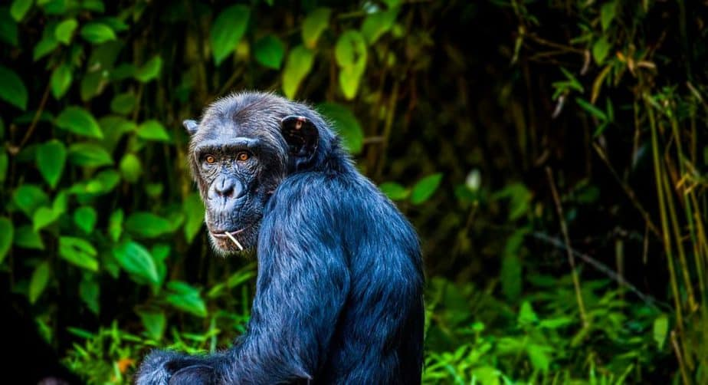
Well first of all meet Congo the chimp artist!!!

An artist called Desmond Morris put a brush in the hand of a two-year-old chimpanzee named Congo and waiting to see what “works of art” the little ape would create. Here are two of them!
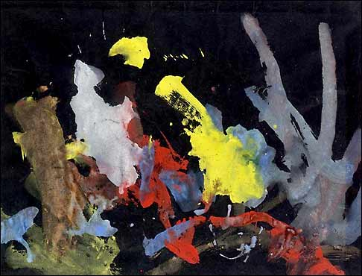
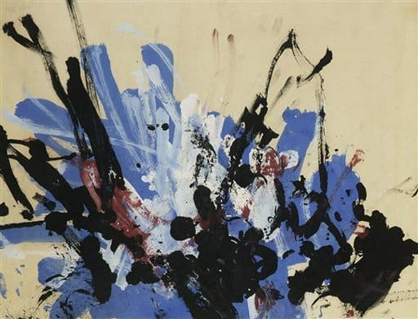

Congo the ape was allowed to use his artistic creativity, producing a total of more than 400 abstract paintings. This was particularly remarkable due to the fact that neither Desmond Morris nor anyone else had ever shown the monkey how to paint or how art “works”.
The famous artist Pablo Picasso was a fan of the chimpanzee painter and bought individual paintings for his own private collection.
In 2005, a London auction house auctioned three paintings by the ape artist for more than £14,000!!!

So, what actually is abstract art?

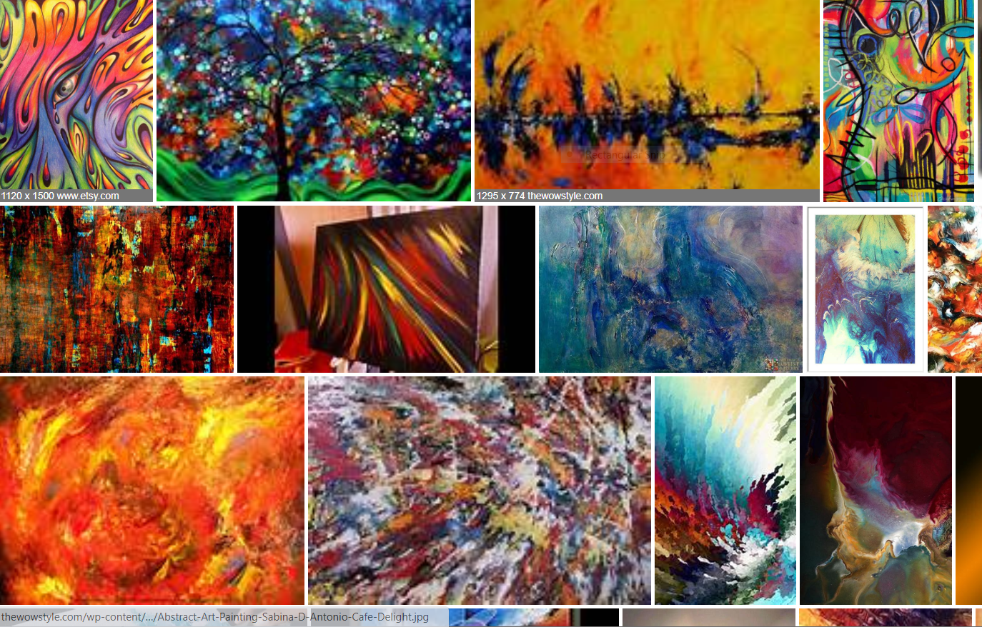

Look at lots of examples of abstract art.
Understanding abstract art is easy: all it requires is an open mind and a big imagination.
Abstract art requires you to have an inquiring mind; you must enter the painting and see where it takes you.
Abstract art is an experience. Let your eyes wander over the paintings. Let your eyes play with the painting, slipping around corners, following the twirls, twists and turns, dipping in and out of the surface. Let your eyes dance around the piece. That is abstract art.
To do: Now the fun part! It’s your turn to do some abstract art. Use paint if possible, but crayons are fine. Let your imagination run wild and enjoy creating your works of art.

Happy safe summer everyone!

